Physical Computing Self-Quiz

The following are questions you should be able to answer without reference to outside material by the middle of the semeter in Introduction to Physical Computing. Try to answer all of the questions below without resorting to copying external code or diagrams. If you don't know where to start on a given question, consult with your instructor in office hours.

Give a definition for physical interaction.

Explain the difference between an analog sensor and a digital sensor. Give examples of both.

How do you determine how the range of resolution you need from a given sensor or output device (actuator)?

Identify the electronic components in this diagram:
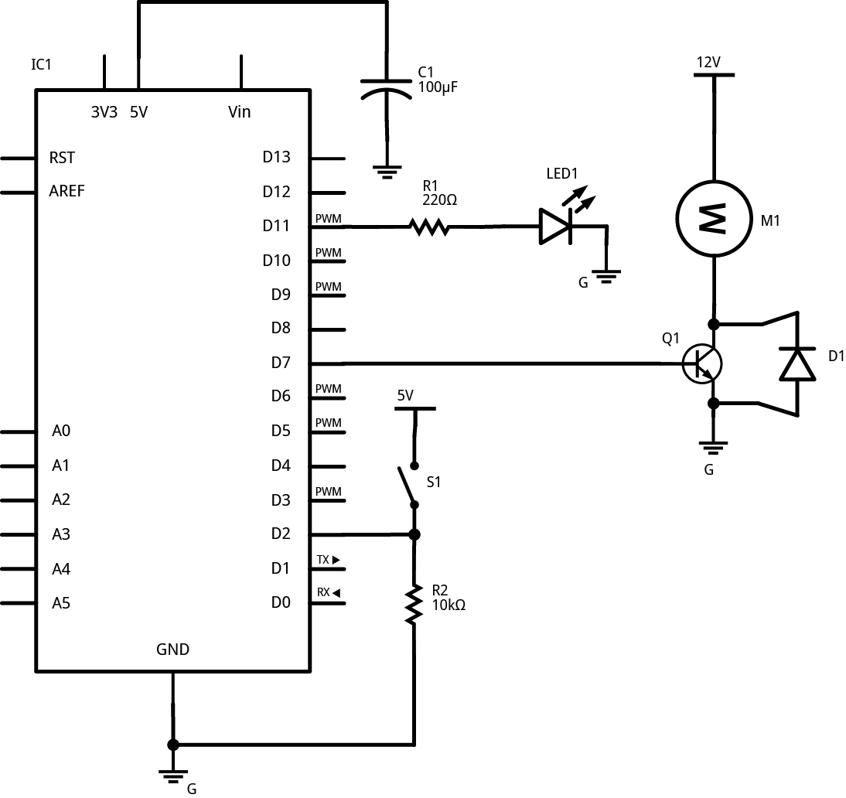 | R1, R2:  C1:  IC1:  Q1:  D1:  LED1:  M1:  G:

Calculate the value for the resistor in the following circuit:
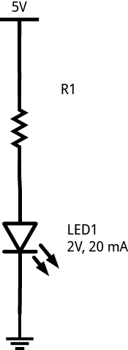
If you wanted to make the LED in the circuit above dimmer, what change would you make to the resistor?

Identify the components that are in series below, and those that are in parallel:

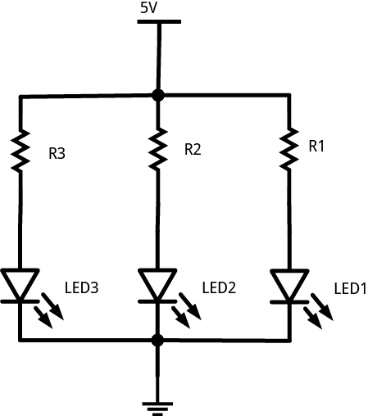

Fill in the blanks:
When components are in series, the _________ through them is the same.
When components are in parallel, the _________ across them is the same.

Make a schematic diagram of the following circuit:
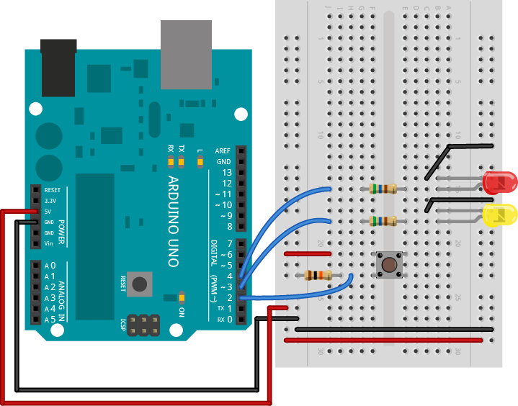
What are the following components most commonly used for:

Transistor

Diode

Resistor

Potentiometer

H-Bridge

Draw the circuit for connecting a switch to a microcontroller's digital input pin, using a pulldown resistor.

Draw the circuit for connecting a potentiometer to a microcontroller's analog input pin.

Draw the circuit for connecting a variable resistor to a microcontroller's analog input pin, using a voltage divider.

Write a program to read a digital input on an Arduino and print the result out to the serial monitor.

Write a program to read a digital input on an Arduino, compare the current reading to the last reading, and if the state of the input has changed, print the result out to the serial monitor.

A potentiometer attached to an Arduino's analog input returns a result of 435 when read using the analogRead() command. What is the voltage between the input and ground?

Write a program to read an analog input on an Arduino, map the result to a range from 0 to 255, and fade an LED.

Write a program to read an analog input on an Arduino and send the result serially to a desktop computer in a single byte.

Write a program to read three analog inputs on an Arduino and send the results serially to a desktop computer as an ASCII string, separated by commas, and terminated by a newline and carriage return.

